Unit-I
Introduction to software Engineering
The Evolving role of software
Definition of software
Software is a set of items or objects that form a “configuration” that includes
• Programs
• Documents
• Data
Software’s Dual Role
- Software is a product
  - Delivers computing potential
  - Produces, manages, acquires, modifies, displays, or transmits information
- Software is a vehicle for delivering a product
  - Supports or directly provides system functionality
  - Controls other programs (e.g., an operating system)
  - Effects communications (e.g., networking software)
  - Helps build other software (e.g., software tools)
Software Characteristics
Software is developed or engineered; it is not manufactured in the classical sense.
Although some similarities exist between software development & hardware manufacturing both the activities are different. In both activities high quality is achieved through good design, but manufacturing phase will introduce quality problems that are non-existent in software. Both activities depend on people but relationship between people applied and work accomplished is different.
Software does not wear out. However it deteriorates due to change
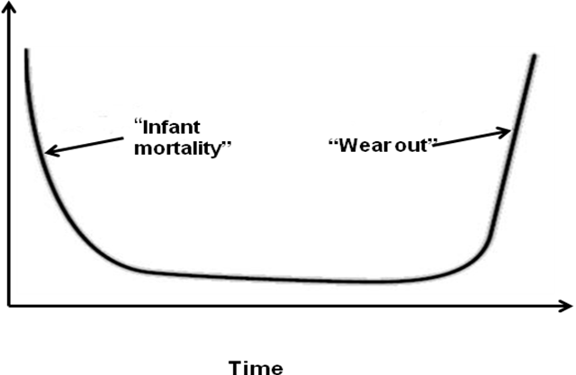Fig:Failure curve for h/w
I t indicates that hardware exhibits high failure rates early in its life. Defects are corrected, and failure rate drops to a steady-state level for some period of time. As time passes, the failure rate rises again as hardware components suffer from cumulative effects of dust, temperature and other environmental maladies. Simply hardware begins to wear out.
Fig: failure curve or s/w
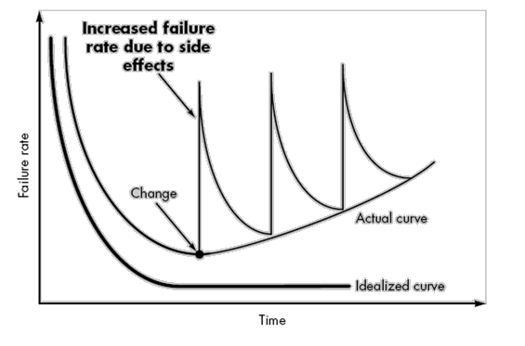
Software doesn’t wear out so it should take form of idealized curve. Undiscovered defects will cause high failure rates early in its life of a program. However these are corrected and curve flattens the actual curve shows that during its life software will undergo change. As changes are made, it is likely that errors will be introduced, causing failure rate curve to spike again. Before curve can return to original state, another change is requested, causing curve to spike again. Slowly failure rate level begins to rise – the software is deteriorating due to change.
-Although the industry is moving towards component based construction, most software continues to be custom built
Custom-built: building according to needs of customer
The main of component-based construction is reuse. In the hardware world, component reuse is a natural part of engineering process. In software world it has only begun to achieve on a broad scale.
Evolution of software:
1950’s-60’s (mid): Batch orientation, limited distribution
1960’s (mid)-1970’s (mid): multiuser, realtime, database, product s/w
1970’s mid-1980’s (late): distributed systems, low cost h/w, and consumer impact s/w
1980’s (late)-2000: object-oriented techniques, artificial neural networks.
Changing Nature of Software
- Seven Broad Categories of software are challenges for software engineers
- System software: System software is a collection of programs written to service other programs
Software is determinate is the order and timing of its inputs, processing, and outputs is predictable (Ex compiler, file management utilities)
Indeterminate if the order and timing of its input, processing, and outputs is not predictable in advance. (Ex: networking software, operating system components)
- Application software: This is designed to help users in order to perform a specific task. Applications in this area process business or technical data.Ex:C,JAVA
- Engineering and scientific software: Engineering and scientific software have been characterized by "number crunching" algorithms (which performs complex, lengthy and complex numeric calculations).However modern applications are moving away from numeric algorithms to computer-aided design, system simulation.
- Embedded software: It resides within a product or system and is used to implement and control features and functions of end-user and system itself.
Ex: Keypad control of microwave oven, fuel control etc
- Product-line software: Designed to provide a specific capability for se by many different customers.
Ex: Computer Graphics, entertainment, databasemanagement.
- Web-applications: These are applications which are accessed over a network.
- Artificial intelligence software: Artificial intelligence (AI) software makes use of nonnumeric algorithms to solve complex problems that are not amenable to computation or straightforward analysis
Ex: Robotics, Expertsystems, gameplaying etc.
SOFTWARE MYTHS:
- Propagate misinformation and confusion
- Three types of myths
- Management myth
- Customer myth
- Practitioner’s myth
Myth (1)
-Already we have a book of standards and procedures for building software wont that provide my people with everything they need to know?
Reality: The book of standards may very well exist but is it used? Are software practitioners aware of its existence? Is it complete? Is it adaptable?
Myth (2)
-If we get behind schedule we can add more programmers and can catch up.
Reality: As new people are added, people who were working must spend time educating the newcomers, thereby reducing amount of time spent on productive development effort.
Myth (3)
-Outsourcing the software project to third party, we can relax and let that party build it.
Reality: If an organization doesn’t understand how to manage and control software projects internally, will face struggle when it outsources projects.
CUSTOMER MYTHS
Myth (1)
General statement of objective is enough to begin writing programs, the details can be filled in later.
Reality: Unambiguous requirements can be developed only through efficient and continuous communication between developer and customer.
Myth (2)
-Software requirements continually change but change can be easily accommodated because software is flexible.
Reality: When requirement changes are requested early cost impact is relatively small. However as time passes cost impact grows rapidly.
Practitioner myths:
Myth (1)
-Once the program is written, the job has been done.
Reality: Industry data indicate that between 60 and 80 percent of all effort expended on software will be expended after it is delivered to customer for first time.
Myth (2)
Until the program is running, there is no way of assessing the quality.
Reality: Formal technical reviews have been found more effective than actual testing
Myth (3)
-The only deliverable work product is the working program
Reality: A working program is only part of software configuration. Documentation provides a foundation for successful engineering.
Myth (4)
-Software Engineering creates voluminous and unnecessary documentation and invariably slows down software development.
Reality: S.E is not about creating documents. It is about creating quality. Better quality leads to reduced rework.
SOFTWARE ENGINEERING-A LAYERED TECHNOLOGY:
Software Engineering Definitions
Software engineering: (1) The application of systematic, disciplined quantifiable approach to the development, operation, and maintenance of software; that is ,the application of engineering to software (2)the study of approaches in (1).


Quality focus: Bedrock that supports software Engineering.
Process - Foundation for software Engineering. It defines a framework that must be established for effective delivery of software engineering technology. This provides a basis for management control of software projects.
Methods: Provide technical how-to’s for building Software. Methods encompass a broad array of tasks that include
- Communication
- Requirements analysis
- design modeling
- Program construction
- testing
- Support
Tools:- Provide semi-automatic and automatic support to methods. When well-integrated, it is a CASE system.(Computer-Aided Software Engineering)
Process framework
A Process Framework establishes the foundation for a complete software process by identifying a small number of framework activities that are applicable to all s/w projects, regardless of size/complexity and set of umbrella activities which are applicable across entire s/w process
Each framework activity is populated by a set of software engineering action-collection of related tasks that produce a major engineering work product
These are the 5 framework activities
Communication: This activity involves heavy communication and collaboration with customer and encompasses requirements gathering.
Planning: It establishes a software project plan for software engineering work that follows. It describes technical tasks to be conducted, risks that are likely, resources that will be required, work product to be produced and a work schedule.
Modeling: This activity encompasses creating models that allows customer to better understand software requirements and design.
Construction: This activity combines code generation and testing.
Deployment : The software is delivered to customer who evaluates the delivered product and provides feedback.
Each Software engineering action is represented by a number of task sets. The task set that best accommodates the needs o project and characteristics of team is chosen.
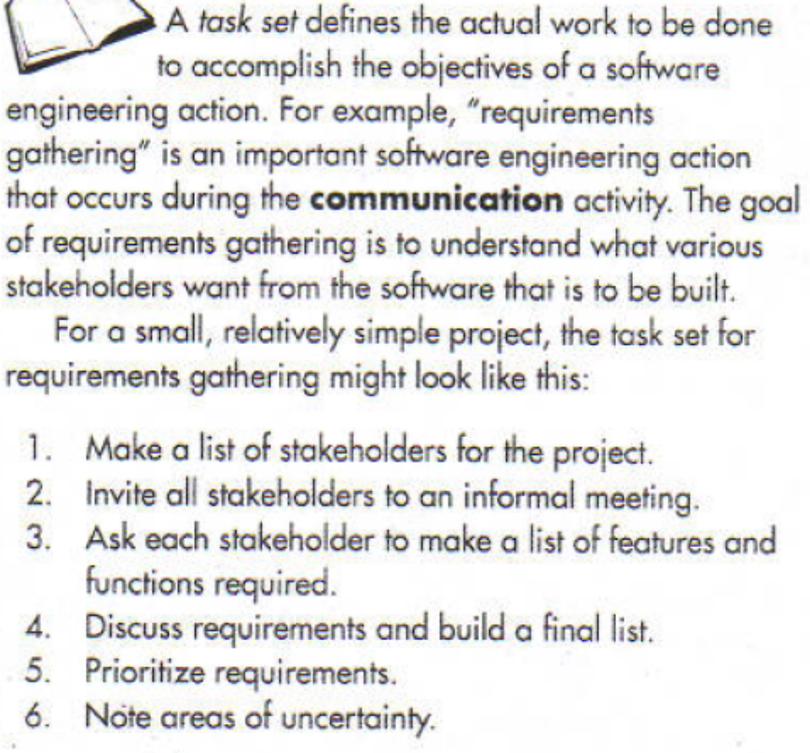
.
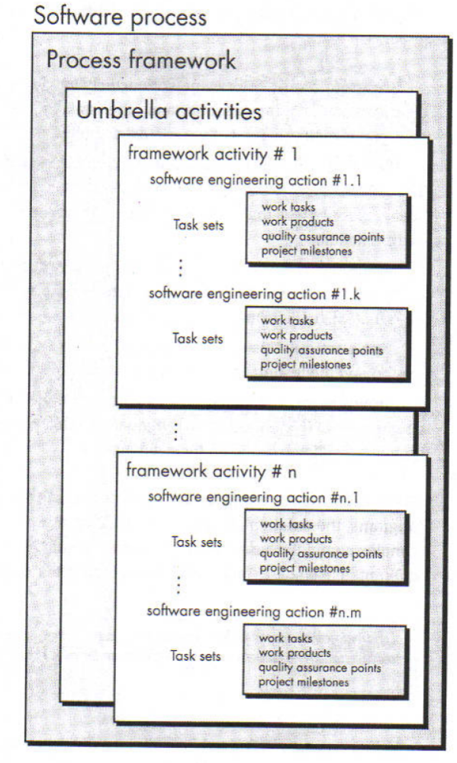
Umbrella activities
Software project tracking and control: asses progress against project plan and take necessary action to maintain schedule.
Formal technical reviews: Assesses software engineering work products in an effort to uncover or remove errors before they are propagated to next action.
Software quality assurance: defines and conducts activities required to ensure quality
Software configuration management; manages change throughout the process.
Work product preparation and production: encompasses activities required to create work products such as documents, forms,logs reports etc.
Reusability management: Defines criteria for work product reuse and establishes mechanisms to achieve reusable components.
Measurement: Defines and collects process, project and product measures that assist team in delivering software that meets customer needs
Risk management: assesses risks that may affect outcome of project and quality

CAPABILITY MATURITY MODEL INTEGRATION
Developed by SEI(Software Engineering institute)
Assess the process model followed by an organization and rate the organization with different levels
A set of software engineering capabilities should be present as organizations reach different levels of process capability and maturity.
CMMI process Meta model can be represented in different ways
1. A continuous model
2. A staged model
Continuous model:
- -Levels are called capability levels.
-Describes a process in 2 dimensions
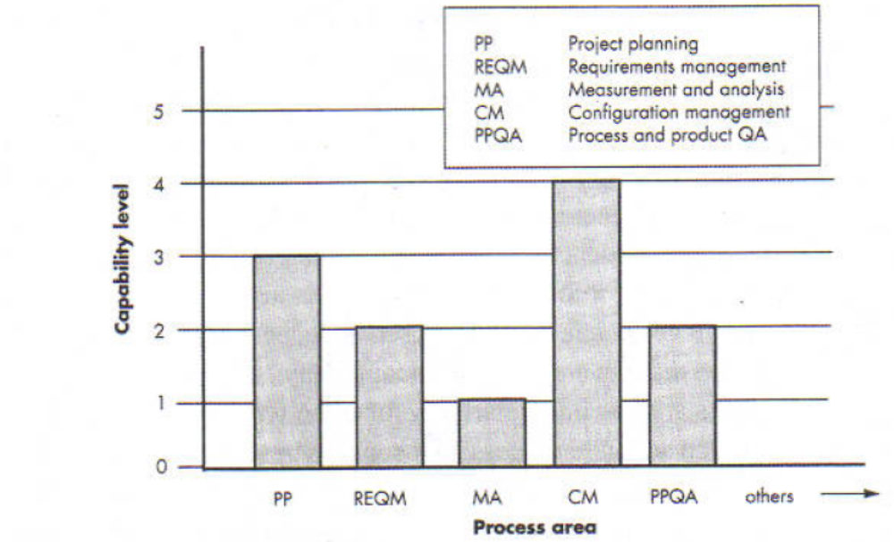
-Each process area is assessed against specific goals and practices and is rated according to the following capability levels.

Six levels of CMMI
  - Level 0:Incomplete
  - Level 1:Performed
  - Level 2:Managed
  - Level 3:Defined
  - Level 4:Quantitatively managed
  - Level 5:Optimized

INCOMPLETE
-Process is adhoc.Objective and goal of process areas are not known
Performed
All the specific goals and practices process area have been satisfied but performance may not be stable they do not meet some specific objectives such as quality, cost and schedule
Managed
-Activities are monitored, reviewed, evaluated and controlled to achieve a given purpose and cost, schedule, quality are maintained. These companies have some planned processes within teams and teams are made to represent them for projects handled by them. However processes are not standardized across organization.
Defined
-All level2 criteria have been satisfied and in addition process are well defined and are followed throughout the organization
Quantitatively Managed
-Metrics and indicators are available to measure the process and quality
Optimized (perfect&complete)
- Continuous process improvement based on quantitative feedback from the user
-Use of innovative ideas and techniques, statistical quality control and other methods for process improvement.
In addition to specific goals and practices for each process area 5 generic goals correspond to capability levels. In order to achieve a particular capability level the generic goal for that level and generic practices correspond to the goal must be achieved.
Staged model
- This model is used if you have no clue of how to improve the process for quality software.
- It gives a suggestion of what things other organizations have found helpful to work first
- Levels are called maturity levels
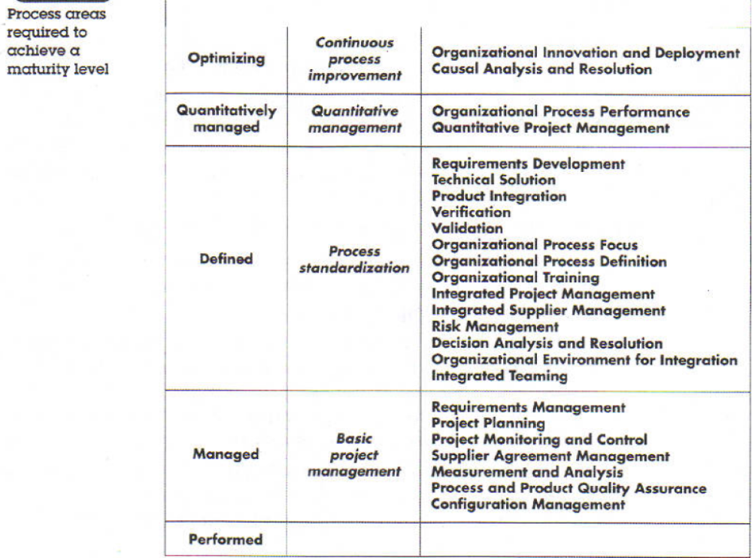

Process patterns
- The software process can be defined as a collection of patterns that define a set of activities, actions, work tasks, work products and/or related behaviors.
- A process pattern provides us with a template. A consistent method for describing an important characteristic of s/w process.
- Patterns can be defined at any level of abstraction. In some cases it is used to define complete process (e.g. prototyping).In other situations patterns can be used to describe an important framework activity(e.g. planning) or a task within a framework activity(e.g. project-estimating).
- Pattern Template
-Pattern Name: The pattern given a meaningful name that describes its function within the software process. (e.g. requirements unclear)
-Intent: The objective of pattern is described briefly. For ex the objective of pattern is to build a model that can be assessed iteratively by stakeholders.
-Type: pattern type is specified. Suggests 3 types
-Task pattern: defines a software engineering action or work task that is part o process (e.g. requirements gathering)
- Stage pattern: defines a framework activity for the process (e.g. communication)
-Phase Pattern: defines sequence of framework activities that occur with the process (ex spiral model or prototyping)
Initial Context: The condition under which pattern applies are described. Prior to initiation of pattern the following conditions must be met

For ex:1) stakeholders have been identified 2) mode of communication between software team and stakeholder has been established. 3) Problem to be solved has been identified by stakeholders.4) an initial understanding of reqirements has been developed
Problem: The problem to be solved by pattern is described.
Ex: Requirements are hazy or non-existent i.e., stakeholders are unsure of what they want. that is they cannot describe software requirements in detail.
Solution: The implementation of pattern is described ex: A description of prototyping process is described here.
Resulting Context: The conditions that ill result once the pattern has been successfully implemented are described.
Ex:1)A software prototype that identifies basic requirements are approved by stakeholders
And a prototype may evolve through a series of increments to become production software.
Related Patterns: A list of process patterns that are related to this one are provided.
Ex: customer-communication, iterative design&development, customer assessment, requirements extraction.
Known uses and examples: The specific instances in which pattern are applicable are indicated.

PROCESS ASSESSMENT
- It attempts to keep a check on the current state of the software process with the intention of improving it.
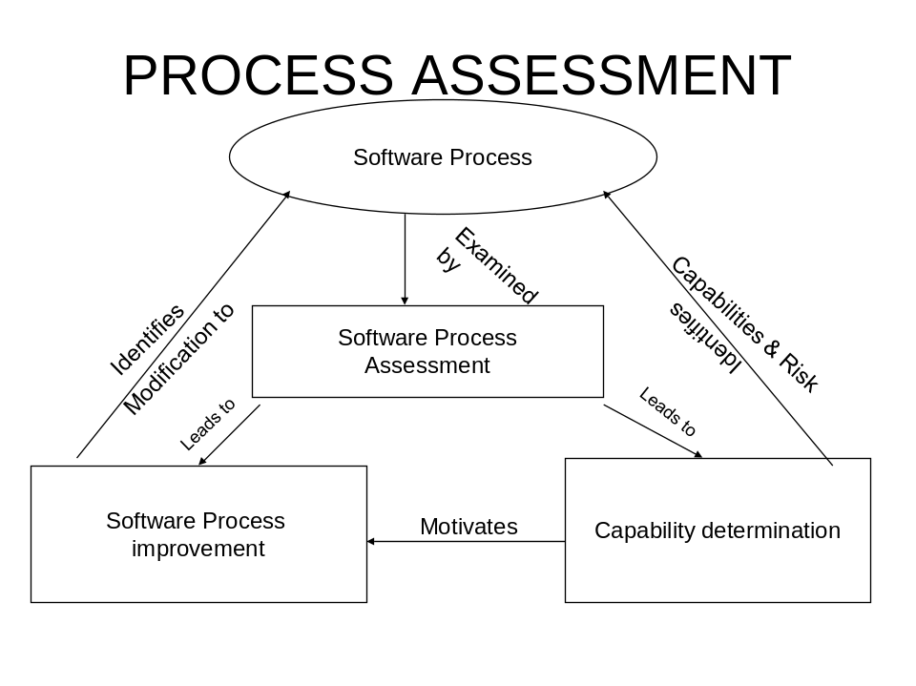
- Standard CMMI assessment for process improvement (SCAMPI): provides a 5 step process assessment model that incorporates initiating, diagnosing, establishing, acting and learning. The SCAMPI uses SEI CMMI as basis for assessment.
- CMM based appraisal for internal process improvement: provides a diagnostic technique for assessing relative maturity of a software organization
- SPICE(ISO/IEC 15504):standard defines a set of requirements or sotware process assessment
- ISO 9001:2000 for software: is a generic standard that applies to any organization that wants to improve overall quality of products, systems or services that it provides.

